A Systemic Framework for Assessing the Risk of Decarbonization to Regional Manufacturing Activities in the European Union

Giorgio Coppola^{1,2,3}, Soheil Shayegh^{1,2*}
¹ CMCC Foundation - Euro-Mediterranean Center on Climate Change, Italy
² RFF-CMCC European Institute on Economics and the Environment, Italy
³ Hertie School, Germany.
*Email: soheil.shayegh@cmcc.it

Abstract
Ambitious decarbonization policies of the European Union (EU) pose new challenges and opportunities for the industries and businesses across the continent. We introduce a new framework for the systemic assessment of decarbonization risks that the EU regional manufacturing entities are facing. The composite risk score captures both the exposure of EU manufacturing enterprises to regional emissions and their vulnerability to fully embrace the EU climate policy agenda and to adopt proper decarbonization measures. We combine five dimensions of energy, labor, finance, supply chain, technology, and institution to build a composite index of vulnerability capturing regional disparities in accessing critical resources needed to achieve decarbonization targets. The results show a high degree of heterogeneity across the EU NUTS 2 regions with some regions in the Netherlands, Belgium, and northern Germany at highest risk due to existence of fossil-dependent heavy industrial activities while some Scandinavian regions specially in Sweden enjoy lower risk of decarbonization to their manufacturing sector due to high availability of renewable energy, skilled labor, and financial capital.

Key policy insights:
- Decarbonization policies pose a heterogenous risk to local businesses across the EU. Decarbonization risk harmonization and quantification will allow EU industrial policymakers to identify the vulnerability hotspots where greater efforts and resources are needed.
- Regional manufacturing in hard-to-abate sectors are generally more exposed to the impacts of emissions reduction policies, but this exposure varies depending on the energy input mix and the characteristics of manufacturing technology. Industrial regions in some regions in northern Europe with high share of fossil fuel consumption are more likely to suffer from stricter emission regulations.
- Decarbonization vulnerability is driven mainly by energy needs and resource availability. Less industrialized regions in southern Europe are more vulnerable to decarbonization policies due to their limited access to adequate financial and human capital while industrialized northern regions are more vulnerable due to their high dependency on imported fossil fuels.

Introduction
Tackling global climate change requires deep decarbonization and fast transition to a low- and zero-emission economy which will affect many aspects of society including a radical change in the production and delivery of goods and services. The “green” transition has intensified in recent years and especially after the Paris Agreement. Deep decarbonization requires an understanding of the significant changes necessary in the society and its underlying impacts on the socio-economic structures. It includes both large-scale macro-level decisions about economic and energy policies and small-scale micro-level decisions about programs and operations that affect cities, citizens, and businesses at the local level.
At the European level, the European Union (EU) has recognized the urgency of green transition and has put forward several policy packages and climate initiatives including the European Green Deal aimed at making the EU an exemplary region in terms of achieving climate-neutrality status by 2050. To enforce the EU’s intermediate and long-term objectives, and in line with the European Green Deal, the European Climate Law was adopted in 2021 and a new strategy on adaptation to climate change was developed with a vision for making the EU a climate-resilient society by 2050. Finally, the EU adopted a wide range of policy reforms under the umbrella of the “Fit for 55” package to achieve at least 55% reduction in greenhouse gas (GHG) emissions by 2030. Together, these measures tighten the EU Emissions Trading System, introduce the Carbon Border Adjustment Mechanism, and mandate progressively stricter efficiency and product-carbon standards – policy levers that raise the cost of carbon-intensive production.
At the country level, following the overarching EU’s climate policies and implementing national long-term strategies (LTS) are essential for achieving the necessary economic transformation. However, as EU regions differ significantly in socio-economic and productive structures (EEA, 2024), various trade-offs between costs and benefits of the green transition may emerge in different parts of the EU (Vrontisi et al., 2020; 2024; Fragkos et al., 2021). Understanding such trade-offs will enable regional actors, including local businesses, not only to actively participate in and benefit from the green transition but also recognize their vulnerabilities and better prepare for the inevitable risks from this transition. In this paper, we develop a framework for assessing the readiness of the regional economic sectors and businesses to embrace decarbonization and transition to a sustainable economy.
This analysis focuses specifically on the manufacturing sector as it is responsible for 21% of total GHG emissions in the EU. This sector is also considered highly strategic in maintaining the EU’s competitiveness. In 2022, the manufacturing industry in the EU emitted 745 million tons of carbon dioxide equivalents (CO2-eq), the second highest level of emissions after “electricity, gas, steam, and air conditioning” (Eurostat, 2023). To achieve the EU’s climate objectives therefore, it is crucial to identify manufacturing subsectors in geographical areas with high emission levels –, where decarbonization is urgently needed, and to assess its socio-economic impact on local industries (Jäger, 2023; Raillard–Cazanove et al., 2024).
In this paper, we consider the notions of vulnerability and risk in this context, identifying regions most susceptible to the low-carbon transition. This will help European, national, and regional decision makers with design policies that mitigate potential negative impacts of the green transition. These impacts, if not addressed properly, may reduce local support for climate policies (Carley & Konisky, 2020; Rodríguez-Pose & Bartalucci, 2024).
Emissions from manufacturing activities vary significantly among sub-sectors and between regions. While certain industries, particularly those characterized as "hard-to-abate" such as steel, cement, and chemical manufacturing, face more pronounced challenges due to their high emission profiles and limited availability of effective and economically viable decarbonization technologies, the geographic location where the manufacturing facilities are located can either facilitate the transition to low-emission production or hinder such initiatives. Therefore, understanding the differences among subsectors and between regions is key to managing the transition effectively. In this regard, the transition risk is associated with not only the emission intensity of manufacturing processes, but also the varying levels of preparedness and adaptive capacity among different manufacturing subsectors and regions.
Hence, the main contribution of this paper is to propose a comprehensive theoretical and empirical framework, in the form of a composite “Transition Risk Index" that evaluates regional vulnerability across EU’s manufacturing subsectors. This framework aims to identify industries and regions at higher risk during the low-carbon transition, highlighting their specific needs in line with principles of a just transition. It helps policymakers allocate resources more effectively to subsectors facing the greatest risks, enabling them to prioritize interventions and support measures accordingly. While the index is not designed to evaluate the impact of any particular climate policy, it provides an overall assessment of the readiness of the European regional manufacturing economic structure to the challenges derived from the green transition.

Literature Review
The concepts of vulnerability and risk are prevalent in climate change literature. Although much attention has been given to climate risks, the risks associated with decarbonization pathways – often termed "transition risks" – have not been sufficiently explored, particularly at the local level. Similarly, while socioeconomic vulnerability of local communities and regions to climate change has been the subject of growing interest within the climate change impact community, less attention has been paid to vulnerability at the industrial sector level (Lo et al., 2021), as most studies tend to focus on the economy as a whole (Eklund et al., 2023).
Yet, the few studies that consider the vulnerability of local businesses or specific economic sectors have mainly focused on the potential and realized physical impacts of climate change and how local enterprises can adapt (Lo et al., 2019). As a result, the vulnerability of regional economic activities has been mainly defined and understood as the sensitivity of business operations to changes in their environment from the risk of floods and sea-level rise (Davlasheridze & Geylani, 2017; Song et al., 2016), to rising temperature affecting tourism (Brouder & Lundmark, 2011).
Previous studies have examined similar topics from various perspectives. In the European context, Rodríguez-Pose and Bartalucci (2024) identified regional impacts of the green transition across five sectors (transportation, energy, agriculture, tourism and industry), considering reliance on fossil-fuels and CO₂ emissions as direct factors of vulnerability, and labor and capital reallocation as indirect factors of vulnerability. Focusing specifically on socioeconomic risk, Vrontisi et al. (2024) studied the impact on the change of domestic production in 2050 from 2015 levels for the fossil-fuel related sectors, in terms of employment in these sectors and a series of socio-economic regional characteristics. They identified EU regions that face heightened vulnerability during the low‐carbon transition. In addition, McDowall et al. (2023) mapped regional vulnerability in Europe by developing an indicator to assess declining employment in four carbon-intensive industries. In the United States, Carley et al. (2018) and Hincapie-Ossa et al. (2023) assessed county-level vulnerability to the energy transition using machine learning approaches, while Graham and Knittel (2024) evaluated the distribution of employment vulnerability by employing carbon footprints.
Case studies further enrich this discussion. Voßbeck and Fastenrath (2024) investigated the resilience of regional industrial decarbonization pathways with insights from the building materials industry in Lower Austria, and Sasse and Trutnevyte (2023) demonstrated that a low-carbon electricity sector in Europe risks sustaining regional inequalities in benefits and vulnerabilities. Moreover, Jäger (2023) examined EU policies affecting energy-intensive industries, highlighting challenges at the sectoral level even when not directly focusing on regional disparities.
When it comes to local industry vulnerability, most existing studies have concentrated on the impacts of climate hazards on business operations. For instance, Davlasheridze and Geylani (2017) investigated the vulnerability of small businesses to floods and the mitigating effects of disaster loans, whereas Song et al. (2016) developed a theoretical framework for assessing the integrated vulnerability of enterprises to sea level rise. Similarly, Brouder and Lundmark (2011) explored intra-regional perceptions of vulnerability among winter-oriented tourism businesses in Northern Sweden. Against this backdrop, the concept of business vulnerability and risk can be expanded to measure the readiness of local industry to embrace decarbonization and transition to a greener economy. In this sense, vulnerability to decarbonization encompasses how businesses are prepared for a green transition.
Vulnerability, however, is only one component of risk. The Sixth Assessment Report of IPCC (AR6) defines climate-related risks as a function of vulnerability, hazard, and exposure (IPCC, 2023). Here we adopt a reformulation of the IPCC risk assessment framework to study decarbonization risk instead of climate change risk, like some of the previous studies in this domain (Vrontisi et al., 2024; McDowall et al., 2023; Carley et al., 2018).

Theoretical Framework
We develop a theoretical and empirical framework for assessing decarbonization risk to businesses in the manufacturing sector. This framework considers both internal and external factors, enabling a comparative analysis of decarbonization risk across different regions and sectors.
The transition to a low-carbon economy is an imperative global objective, driven by the need to mitigate climate change and its associated risks. The transition to a low-carbon economy poses “transition risks” for carbon-intensive industries, especially in industrialized regions. The EU’s ambitious climate policies packages entail carbon pricing (e.g., the EU Emissions Trading System), stricter regulations, and incentives for cleaner technologies. Thus, the EU regions whose economies rely heavily on high-emitting manufacturing activities face a heightened risk of economic disruption from these decarbonization measures.
The IPCC risk assessment process starts with a climate-related hazard as an event or trend (natural or human induced) that may cause damage to the system. In this context, exposure is associated with “the presence of people, resources and services in places and settings that could be adversely affected”, vulnerability defines “the propensity of the system to be harmed or adversely affected, and encompasses a variety of concepts and elements including the sensitivity of susceptibility to harm and lack of capacity to cope or adapt”, while the response captures “the response of the system in reducing the contribution of aforementioned factors (hazard, vulnerability, and exposure) to the overall risk and its potential damage to the system”. We apply the IPCC risk framework to our case study, focusing on regional businesses and how they are affected by the consequences of the energy transition and the decarbonization pathways.
As mentioned before, most of the literature focuses on regional socio-economic “risk” or “vulnerability” – depending on which IPCC Assessment Framework is taken as blueprint – especially in terms of declining employment or capital reallocation. In contrast, our methodology aims at identifying regions at high risk in a more nuanced manner. First, our analysis is focused on the industrial manufacturing sector, and it analyses the risk to manufacturing for 237 NUTS-2 regions of the EU. The results from this analysis are complementary to the findings from previous literature.
Our analysis differs from previous studies in terms of identifying the decarbonization risk by considering regional differentiations, sub-sectoral characteristics of European manufacturing, and technological and financial resources availability. The focal difference between this work and previous work is the dual focus on regions and subsectors, allowing for a more refined, complete and nuanced understanding of regional sensitivity to decarbonization. Our analysis can be the starting point for further exploration of the synergies and trade-offs that decarbonization offers at the regional level, specifically for the manufacturing sector.
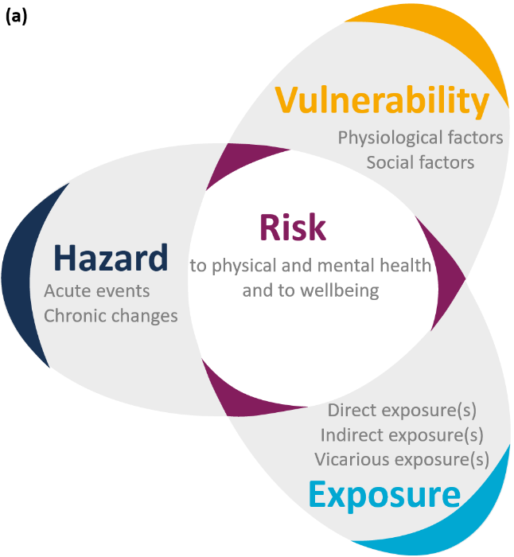 | 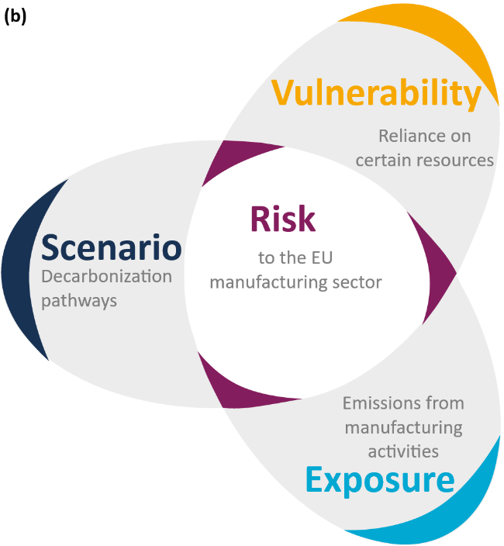
Figure 1: Risk assessment framework (a) according to IPCC AR6 (IPCC., 2022), and (b) our proposal
Figure 1 visualizes risk as a composition of exposure and vulnerability. In our analysis, exposure of a regional industry is proxied by the regional levels of GHG emissions of that sector, and vulnerability is a composite of a variety of indicators influencing regional economic resilience, such as technological availability and financial resource accessibility.
$$Risk=f(Exposure, Vulnerability)$$
Our proposed theoretical framework can be expanded and enhanced by integrating it with modeling outputs describing decarbonization pathways or “scenarios”. This expansion would show how regional patterns of vulnerability are influenced by the pathway to 2050. The decarbonization scenario defines the specific pathways and strategies implemented to achieve emission reductions at the national and regional levels. Such pathways can be further downscaled to provide regional decarbonization pathways which determine the trajectory of GHG emissions across different economic sectors within each region. Each of such regional decarbonization pathways therefore present a risk scenario to local businesses as it requires change in their underlying corporate practices and production processes.

Exposure
In our analysis, Exposure relates to the extent to which a regional manufacturing sub-sector is subject to the impacts of decarbonization, primarily indicated by current GHG emissions levels. In this operationalization, higher emission levels signify greater exposure to decarbonization risks. Regions with high-emitting manufacturing industries inherently face greater exposure, as their economic activities are more directly targeted by climate mitigation policies and economic shifts aimed at reducing emissions. EU climate policies explicitly reinforce this conceptualization.
EU policy explicitly singles out high-GHG sectors as the ones most “exposed” to competitiveness and cost pressures during the transition. Thus, from a policy perspective, GHG intensity equals transition exposure: carbon-intensive manufacturing hubs are squarely in the crosshairs of EU climate action. Conversely, regions and firms that have lower emissions (due to cleaner processes or different sectoral mix) are less directly affected by carbon pricing and mitigation mandates.
GHG emissions, measured at the NUTS-2 regional level and at the NACE rev. 2 sectoral level, thus provide a robust empirical basis for assessing regional and sectoral exposure, allowing identification of both regions inherently susceptible due to their industrial composition and comparative vulnerabilities across regions hosting similar manufacturing subsectors. This dual interpretation reveals variations in regional efficiency, technological advancement, and preparedness for the low-carbon transition.

Vulnerability
Vulnerability in the context of this research captures the capacity – or lack thereof – of regional manufacturing sectors to absorb and adapt to the structural changes associated with decarbonization. Unlike exposure, which focuses on direct emissions levels, vulnerability underscores the techno-economic, institutional, and infrastructural factors that either mitigate or exacerbate the capability of businesses to comply with climate mitigation policies and regulations.
An integrated or “composite” measure of vulnerability is employed to encapsulate the multifaceted nature of the risks faced by regional manufacturing activities. Following recommendations from established guidelines on composite indices (e.g., OECD, 2008) and the IPCC AR6 framework, this approach recognizes that vulnerability cannot be reliably reduced to a single determinant such as employment or R&D spending. Rather, it emerges from the interaction of multiple dimensions, including energy usage, workforce adaptability, supply chain complexity, technological capacity, financial resources, and institutional strength. By combining these interrelated factors into a single index, the analysis can better identify regions where cumulative stresses converge, heightening the likelihood of adverse outcomes under decarbonization pressure. A composite indicator thus provides a consistent method for cross-regional and cross-sector comparisons, highlighting hotspots of vulnerability that may be overlooked when examining isolated indicators. This study adopts six dimensions – Energy, Labor, Supply Chain, Technology, Finance, and Institutions – summarized in Figure 2, to capture the core drivers of vulnerability in regional manufacturing sectors:
- Energy Dimension: The reliance on high-carbon energy sources and the availability of cleaner alternatives has immediate implications for operational costs and compliance under increasingly stringent decarbonization policies. Total energy consumption quantifies the volume of energy that must be decarbonized, while the shares of fossil‐fuels and renewables measure the composition of existing supply and the ease of fuel switching. This dimension assesses how a region’s industrial activities might respond to carbon pricing or stricter emissions targets.
- Labor Dimension: The transition to low-carbon production often requires substantial workforce re-skilling and reallocation. Indicators reflecting advanced skill availability, overall wage levels, unemployment, and labor market slack highlight how readily local labor forces can adapt to greener production processes. Regions with limited workforce preparedness may encounter greater social and economic disruption, reinforcing vulnerability (Eurofound, 2023).
- Supply Chain Dimension: The complexity and global reach of a region’s supply networks expose industrial sectors to climate mitigation policies affecting international trade. By measuring the extent of extra-EU trade flows in manufacturing, this dimension captures how dependent industries may be on external partners – and how exposed they are to instruments like the Carbon Border Adjustment Mechanism (CBAM). High reliance on imported carbon-intensive inputs can intensify vulnerabilities under tightening carbon policies.
- Technology Dimension: Research and development expenditures and innovation capacity contribute to a region’s ability to deploy advanced, energy-efficient processes and digital systems. Regions lacking in these areas may find it challenging to adopt best-available technologies that mitigate emissions. Conversely, robust innovation ecosystems tend to reduce vulnerability by providing industries with the tools and knowledge base to adapt swiftly.
- Finance Dimension: The capacity to finance large-scale infrastructural upgrades and technological retrofits is essential for a successful low-carbon transition. Indicators reflecting public or private investment, financial subsidies, and overall capital formation shed light on a region’s ability to absorb the costs of decarbonization. Regions with limited access to finance or weaker investment climates may struggle to fund comprehensive mitigation strategies, reinforcing vulnerability.
- Institution Dimension: The capacity of a region or a state to effectively govern, implement, and enforce decarbonization policies, while coordinating public and private sector responses, plays an important role. This includes the presence of strong regulatory frameworks, administrative efficiency, local governance quality, and institutional trust.
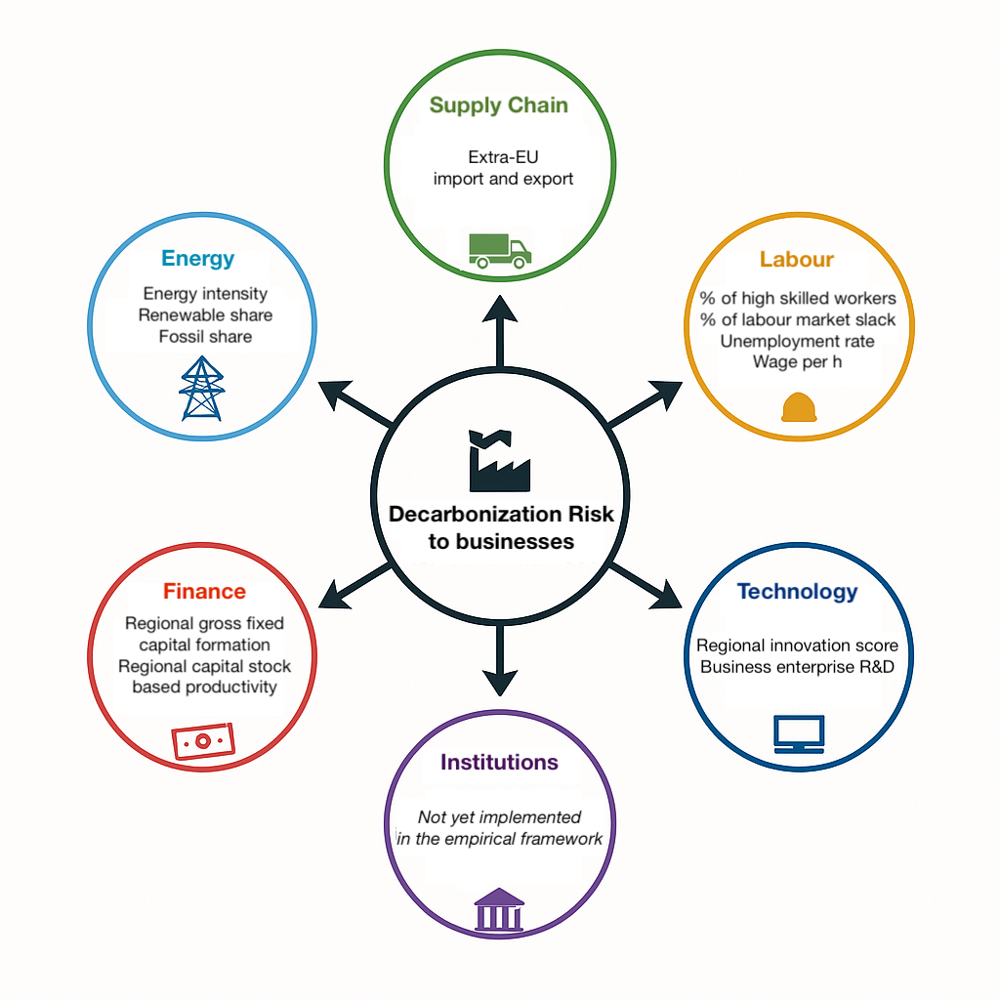
Figure 2: Dimensions of decarbonization vulnerability for regional manufacturing sectors
The composite vulnerability index, derived by aggregating metrics across the six dimensions, enables a comparative assessment of how underlying structural conditions may either cushion or magnify the impacts of decarbonization in each region. Regions scoring highly on the composite index are more likely to experience significant disruptions and may require targeted policy support, workforce development programs, additional investments in technology and infrastructure, or governance reforms to navigate the low-carbon transition effectively.
Certain subsectors also face heightened vulnerability due to constrained access to key decarbonization tools and technologies. Highly energy-intensive industries – such as those using specialized production processes like basic metal production (iron, steel, aluminum, etc.) and non-metallic minerals production (cement, ceramics, lime, glass, etc.) – often encounter technological barriers when attempting to replace established methods with cleaner alternatives, mainly due to the great energy intensity of the operations. In some cases, technologies like carbon capture and storage (CCS) or alternative fuels exist but remain insufficiently mature or cost-prohibitive at scale (IPCC, 2023; OECD, 2023; Wuppertal Institut, 2020).

Risk
Risk emerges as the combined effect of exposure and vulnerability, reflecting how regional manufacturing sectors may be impacted by decarbonization efforts. While exposure measures the direct implications of regional emissions and industrial composition, vulnerability assesses the underlying capacities and resilience of regions to cope with these transitional pressures. Therefore, risk provides an integrated perspective, identifying which sectors and regions are directly affected by decarbonization policies (exposure) and their capacity to effectively adapt to and manage these impacts (vulnerability).
Regions characterized by both high exposure and high vulnerability represent areas of critical concern, as they are likely to face significant transitional challenges. Conversely, regions with high exposure but lower vulnerability may effectively manage transitional pressures through existing adaptive capacities, technological readiness, and institutional robustness. Thus, understanding risk as an interaction of exposure and vulnerability allows policymakers and stakeholders to prioritize resources, customize interventions, and formulate comprehensive transition strategies, fostering a more equitable, inclusive, and successful transition to a sustainable and climate-neutral economy.
The Transition-Risk Index combines a measure of exposure with an aggregate vulnerability index with six dimensions, each capturing a distinct feature of the low-carbon transition. Because these dimensions reflect heterogeneous sources of risk, we aggregate them additively, without imposing the assumption that they co-vary or emanate from a single latent factor. Applied to 237 regions (NUTS-2) and a broad range of manufacturing subsectors, the index is designed as a diagnostic tool that highlights where transition pressures are likely to be most acute rather than as a full structural model of the mechanisms operating within every regional industry.

Methods
The construction of the Transition-Risk Index (TRI) follows the principles laid out in the OECD Handbook on Constructing Composite Indicators (OECD, 2008), with the dual objective of maximizing transparency and preserving the broad, multidimensional character of transition risk. We employ equal weights wherever empirical literature offers no robust hierarchy of importance, and we subject the resulting composite to systematic sensitivity analysis. The procedure unfolds in two sequential layers: (i) aggregation of the vulnerability information scattered across six thematic dimensions and (ii) combination of the aggregate vulnerability score with the sector-specific exposure measure.

Aggregation of vulnerability dimensions
At the indicator level, all variables are normalized to the [0.01, 0.99] interval and directionally aligned such that higher values always indicate greater transition difficulty. Within each dimension indicators are averaged with equal weights to obtain a dimension score ​$S_{d}$. This choice eliminates implicit value judgements and the “dimension-length” bias in the case of dimensions with many indicators. Each dimension is then normalized to the [0.01, 0.99] interval. As mentioned previously, the institutional dimension is excluded from the analysis due to lack of data. The five other dimensions are then combined again by a simple arithmetic mean into an aggregate vulnerability index:
$$V=\frac{1}{5}\sum_{d=1}^{6}{S_{d}}$$
A linear mean is preferred because it remains additively separable, allowing the incremental contribution of any pillar to be interpreted directly.

Aggregation of exposure and vulnerability
The final step merges the normalized exposure score $E$ with the vulnerability index $V$ through the weighted geometric rule
$$TRI={Exposure}^{α}⋅{Vulnerability}^{(1-α)}$$
where $α=0.5$ in the baseline specification. This formulation satisfies four policy-intuitive conditions:
- High exposure and high vulnerability produce high risk
- High exposure but low vulnerability yields moderate risk
- Low exposure but high vulnerability yields moderate risk
- Low exposure and low vulnerability result in low risk.
Equal weighting (EW) was chosen primarily due to the absence of strong theoretical or empirical guidance suggesting differential importance among indicators or vulnerability dimensions (OECD, 2008).
The TRI employs the geometric mean to combine exposure and vulnerability dimensions. This approach is selected specifically for its non-compensatory properties, which ensure that high scores in one dimension (e.g., vulnerability) do not completely offset low scores in another (e.g., exposure). Unlike arithmetic averaging, geometric aggregation penalizes imbalances between these critical components, aligning intuitively with the concept of transition risk, where the simultaneous presence of exposure and vulnerability significantly increases risk. A region with high exposure but negligible vulnerability, or vice versa, should logically reflect lower overall risk compared to regions high in both dimensions. This rationale is also supported by the IPCC framework, which advocates multiplicative or geometric approaches to risk evaluation. Empirical studies confirm that geometric aggregation effectively differentiates high-risk cases from those moderately imbalanced in either exposure or vulnerability alone, thus accurately capturing the nuances of transition risk (OECD, 2008; IPCC, 2023).

Results
Although our framework is applicable to all sub-sectors, here we present the results only for the total manufacturing sector. Figure 3 shows the exposure, vulnerability, and risk scores in every NUTS2 region in the EU. Exposure distribution confirms that regions in industrial parts of the EU including western Germany have the highest emission intensity. On the other hand, these regions generally enjoy a lower aggregate vulnerability while the southern and eastern European regions are more vulnerable to the green transition. As a result of combining these two components, the highest transition risk is observed in western regions of Germany followed by several regions in Spain (Catalonia and the Valencian Community).
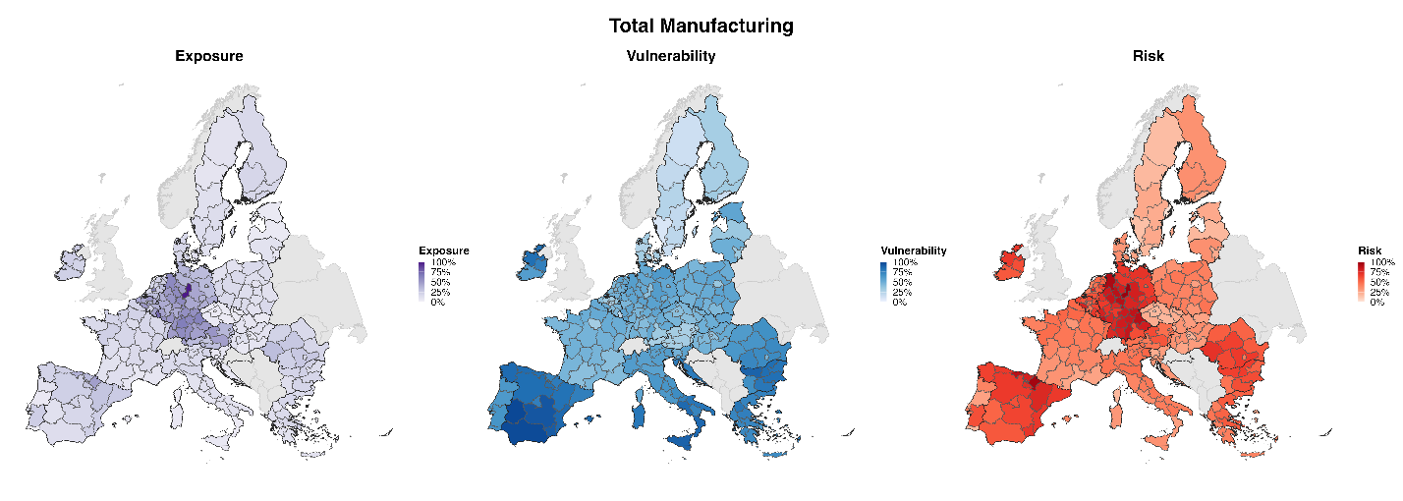
Figure 3: Exposure, aggregate vulnerability, and risk across NUTS2 regions of the EU for the total manufacturing sector.
To understand what drives such results, we can disintegrate the aggregate vulnerability index into its five dimensions. Figure 4 provides the distribution of individual vulnerability scores for each dimension. In terms of Energy, the industrial regions of northern Italy and western regions of Germany have a high dependency to fossil fuel which makes them more vulnerable to transition. On the other hand, these regions usually employ a significant portion of high-skilled labor in their manufacturing sector which lowers their vulnerability while Mediterranean regions in Spain, Greece, and Italy show high share of low-skilled labor and higher vulnerability in this regard. When it comes to supply chain, many regions in Ireland, Germany, and Austria show a great degree of dependency to foreign trade which makes their manufacturing more vulnerable compared to other regions in the EU. In terms of access to high-tech, eastern European regions generally show greater vulnerability while northern regions have the lowest vulnerability. Finally, Spain, Croatia, and Bulgaria suffer from the lack of access to stable financial resources which makes their NUTS2 regions more vulnerable. The combination of these dimensions generates a heterogenous distribution of the aggregate vulnerability across the EU regions as shown in Figure 3. Low-risk regions on the other hand, are mainly in the Scandinavian area where manufacturing activities enjoy access to high share of renewable energy (e.g., 43% in Sweden), skilled labor, and financial capital.
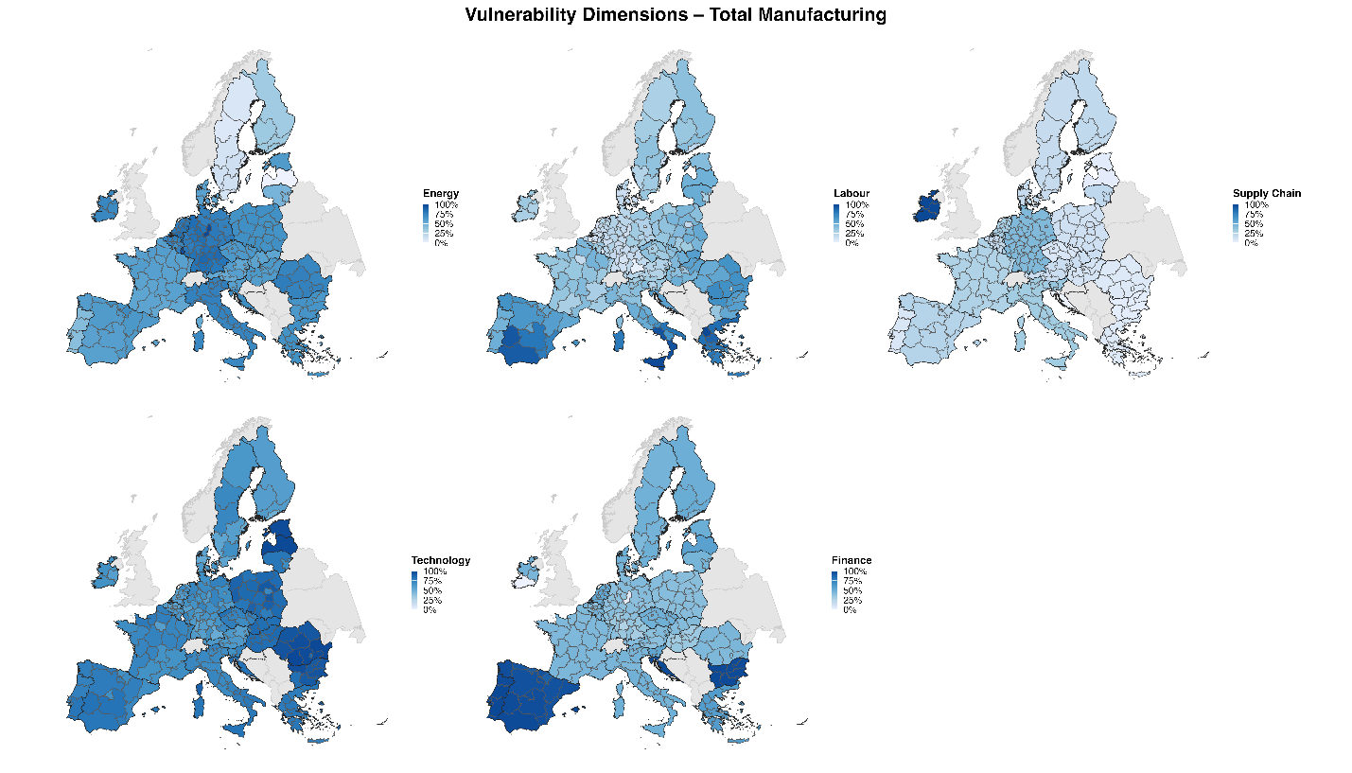
Figure 4: Distribution of vulnerability dimensions across NUTS2 regions of the EU for the total manufacturing sector.
The regional distribution of exposure and vulnerability allows us to further investigate the dominant factors that drive the transition risk in every country and region. Here, we focus on two countries, Germany and Greece, with some of the highest and lowest share of manufacturing in their gross value added (GVA), respectively. In each of these two countries, we pick two regions with highest and lowest transition risk scores as shown in Figure 5.
Comparing the highest and the lowest risk regions in Germany (top row in Figure 5) shows that the manufacturing sector in both regions of Braunschweig and Berlin has a high energy vulnerability, a moderate vulnerability to supply chain and technology, and a low vulnerability to labor. In contrast, emission levels are much higher in Braunschweig than in Berlin while the manufacturing sector in Berlin has slightly higher financial vulnerability. Therefore, the overall risk to decarbonization of the manufacturing sector in Germany seems to be driven by the emission intensity of production processes and high share of fossil fuels in the energy supply mix.
Similarly, comparing two Greek regions with the highest and lowest decarbonization risk (bottom row in Figure 5) reveals that the higher risk of the manufacturing sector in the region of Sterea Ellada is mainly driven by higher exposure to emissions compared to the low-risk region of Voreio Aigaio. As a result, the overall risk scores in these two extreme cases in Greece are closer to each other (57% and 21%) compared to the two extreme cases in Germany (99% and 53%).

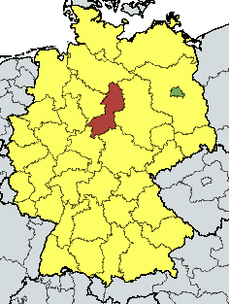 | 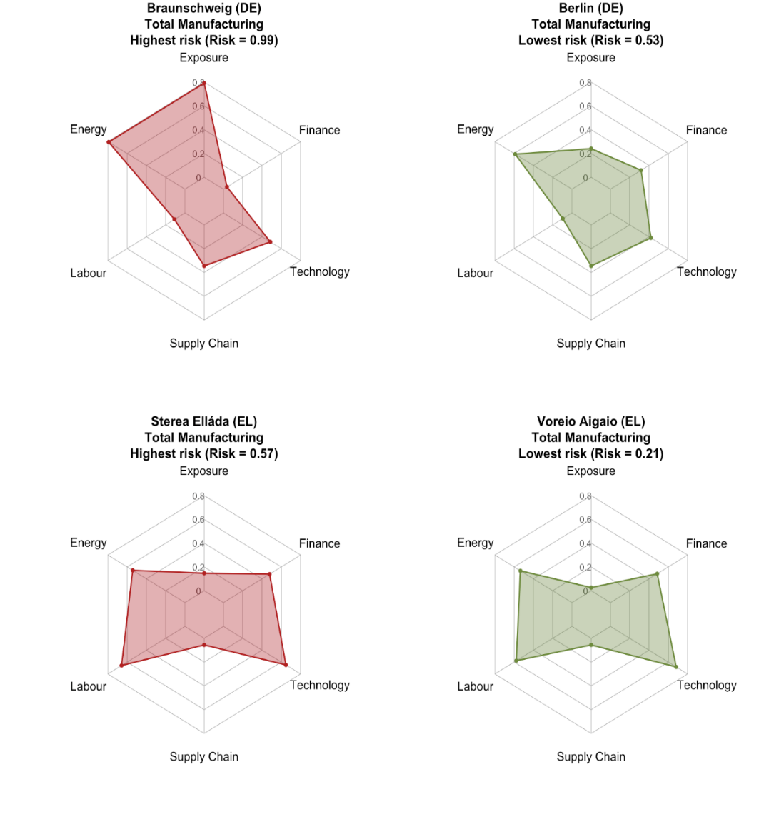
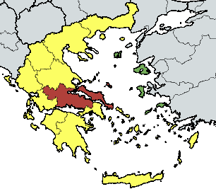
Figure 5: Drivers of decarbonization risk in the NUTS2 regions with the highest risk (left) and the lowest risk (right) in total manufacturing in Germany (top) and Greece (bottom).
We can further investigate the exposure, vulnerability, and risk of decarbonization not only in the total manufacturing sector but also in its subsectors. Figure 6 shows the analysis for the basic metals manufacturing subsector, the most emission intensive manufacturing subsector. Like in Figure 5, here we have also focused on Germany and Greece as the two countries with the highest and lowest share of manufacturing in their gross value added (GVA). In each country we show the two regions with the highest and the lowest decarbonization risk in the basic metal manufacturing sector.
Comparing the high-risk region of Saarland with the low-risk region of Oberbayern in Germany (top row), shows that while the heightened risk of basic metal manufacturing in Saarland is mainly driven by higher emission levels in this region, it is also amplified by relatively higher levels of key vulnerability dimensions including energy, labor, finance, and technology. On the other hand, the two regions in Greece with the highest and the lowest decarbonization risk for basic metal manufacturing (bottom row), show only moderately different exposure and vulnerability along energy and technology dimensions. Here too, the difference between the highest and lowest risk scores in Greece (28% and 14%) is significantly less than the one in Germany (99% and 23%).

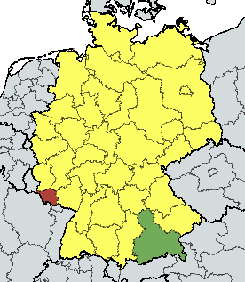 | 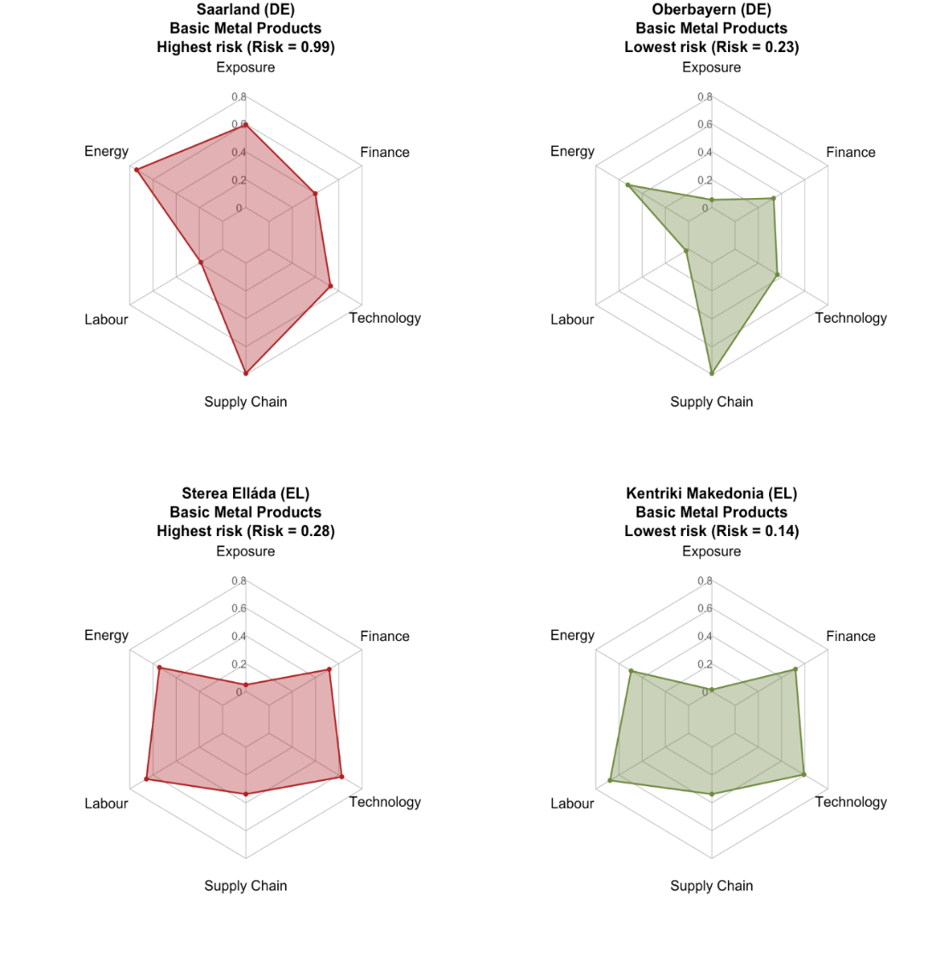
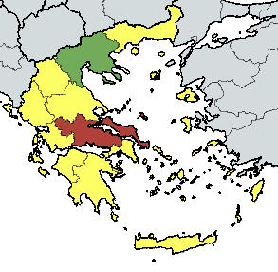
Figure 6: Drivers of decarbonization risk in the NUTS2 regions with the highest risk (left) and the lowest risk (right) in basic metals manufacturing in Germany (top) and Greece (bottom).

Conclusion
As the EU pursues its climate targets of a 55% net reduction in GHG emissions by 2030 and climate neutrality by 2050, many businesses and enterprises across the continent are grappling with intricate challenges of enhancing their competitiveness and securing a reliable energy supply for their operation while undergoing decarbonization and the green transition. This is especially challenging for some hard-to-abate manufacturing subsectors like steel manufacturing, due to the high energy and emission intensity of their operations as a result of deep dependency of these critical sectors to fossil fuels. Furthermore, regional differences in availability of novel technologies and high-skilled labor, accessibility to financial resources, and certainty in policy and regulatory environment place businesses within the same sector at varying levels of readiness to embark on their decarbonization journey. Therefore, to increase their uptake and efficiency, decarbonization regulations and incentives should be informed and adjusted to both sectoral and regional divergencies. Our proposed framework takes the first step in this direction by providing a systemic assessment of regional vulnerability, exposure, and risk of decarbonization for the EU manufacturing sector and its subsectors.
Our findings confirm a high level of heterogeneity in decarbonization risk distribution across the EU NUTS 2 regions. Although industrial regions in western and northern Europe have lower vulnerabilities thanks to their strong technical, financial, and human resources, they exhibit great exposure to emissions due to the high dependence on (foreign) fossil fuel energy sources. In contrast, less-industrialized regions in southern Europe and the Mediterranean are less exposed to emissions but more vulnerable to decarbonization transition due to limited access to adequate technical, financial, and human capital.
While between-country risk score disparities are affected by both vulnerability and exposure, within country heterogeneities are mainly dominated by divergent exposure levels across different regions within the same country. This pattern is more evident in industrialized countries like Germany where within-country regional disparities are greater than between-country differences in risk scores.
Nevertheless, we should emphasize that decarbonization, while imposing operational challenges for regional enterprises, should not be considered as a mere threat but also an opportunity to innovate, adapt, and thrive in a highly competitive world of green solutions enabled by breakthroughs in artificial intelligence (AI) and clean energy supply. Our analysis helps regional businesses and business administrations recognize the barriers to decarbonization which should be mitigated while capitalizing on the advantages that can provide them with a competitive edge.
Like any other empirical method, the applicability of our framework highly depends on the availability and quality of data at the sectoral and the regional level. Critical information about energy and emissions is still missing for some manufacturing subsectors while for some regions with only a few manufacturing units, the normalization of data can generate unintended biases.

References
Brouder, P., & Lundmark, L. (2011). Climate change in Northern Sweden: Intra‐regional perceptions of vulnerability among winter‐oriented tourism businesses. Journal of Sustainable Tourism, 19(8), 919–933.
Carley, S., Evans, T. P., Graff, M., et al. (2018). A framework for evaluating geographic disparities in energy transition vulnerability. Nature Energy, 3, 621–627. https://doi.org/10.1038/s41560-018-0142-z
Carley, S., & Konisky, D. M. (2020). The justice and equity implications of the clean energy transition. Nature Energy, 5, 569–577. https://doi.org/10.1038/s41560-020-0641-6
Davlasheridze, M., & Geylani, P. C. (2017). Small business vulnerability to floods and the effects of disaster loans. Small Business Economics, 49(4), 865–888.
Eklund, G., Sibilia, A., Salvi, A., Antofie, T.-E., Rodomonti, D., Salari, S., Poljansek, K., Marzi, S., Gyenes, Z., & Corbane, C. (2023). Towards a European wide vulnerability framework (JRC Report No. JRC118850). Publications Office of the European Union. https://doi.org/10.2760/353889
Eurofound. (2023). Fit for 55 climate package: Impact on EU employment by 2030, Publications Office of the European Union, Luxembourg. https://doi.org/10.2806/522425
European Environment Agency. (2024). Data viewer on greenhouse gas emissions and removals, sent by countries to UNFCCC and the EU Greenhouse Gas Monitoring Mechanism. https://www.eea.europa.eu/data-and-maps/data/data-viewers/greenhouse-gases-viewer
Eurostat. (2023, December 21). EU economy emissions in 2022: Down 22% since 2008. European Commission. Retrieved April 10, 2025, from https://ec.europa.eu/eurostat/web/products-eurostat-news/w/ddn-20231221-3
Fragkos, P., Fragkiadakis, K., Sovacool, B., Paroussos, L., Vrontisi, Z., & Charalampidis, I. (2021). Equity implications of climate policy: Assessing the social and distributional impacts of emission reduction targets in the European Union. Energy, 237, 121591. https://doi.org/10.1016/j.energy.2021.121591
Graham, K., & Knittel, C. R. (2024). Assessing the distribution of employment vulnerability to the energy transition using employment carbon footprints. Proceedings of the National Academy of Sciences of the United States of America, 121(7), e2314773121. https://doi.org/10.1073/pnas.2314773121
Hincapie-Ossa, D., Frey, N., & Gingerich, D. B. (2023). Assessing county-level vulnerability to the energy transition in the United States using machine learning. Energy Research & Social Science, 100, 103099. https://doi.org/10.1016/j.erss.2023.103099
IPCC. (2023). Climate change 2023: Synthesis report. Contribution of Working Groups I, II and III to the Sixth Assessment Report of the Intergovernmental Panel on Climate Change (H. Lee & J. Romero, Eds.; pp. 35–115). IPCC. https://www.ipcc.ch/report/ar6/syr/
Jäger, P. (2023). Rustbelt relics or future keystone? EU policy for energy‐intensive industries [Working Paper, 13 pages]. Jacques Delors Centre Policy Papers. https://www.delorscentre.eu/en/publications/energy-intensive-industries
Lo, A. Y., Liu, S., Chow, A. S., Pei, Q., Cheung, L. T., & Fok, L. (2021). Business vulnerability assessment: a firm-level analysis of micro-and small businesses in China. Natural Hazards, 108(1), 867-890. https://doi.org/10.1007/s11069-021-04710-z
Lo, A. Y., Liu, S., & Cheung, L. T. (2019). Socio-economic conditions and small business vulnerability to climate change impacts in Hong Kong. Climate and Development, 11(10), 930-942.
McDowall, W., Reinauer, T., Fragkos, P., et al. (2023). Mapping regional vulnerability in Europe’s energy transition: Development and application of an indicator to assess declining employment in four carbon‐intensive industries. Climatic Change, 176, 7. https://doi.org/10.1007/s10584-022-03478-w
OECD. (2023). Regional industrial transitions to climate neutrality (OECD Regional Development Studies). OECD Publishing. https://doi.org/10.1787/35247cc7-en
OECD, European Union, & EC JRC. (2008). Handbook on constructing composite indicators: Methodology and user guide. OECD Publishing. https://doi.org/10.1787/9789264043466-en
Raillard–Cazanove, Q., Rogeau, A., & Girard, R. (2024). Decarbonization modelling for key industrial sectors focusing on process changes in a cost‐optimised pathway. Applied Energy. https://doi.org/10.1016/j.apenergy.2024.125206
Rodríguez-Pose, A., & Bartalucci, F. (2024). The green transition and its potential territorial discontents. Cambridge Journal of Regions, Economy and Society, 17(2), 339–358. https://doi.org/10.1093/cjres/rsad039
Sasse, J. P., & Trutnevyte, E. (2023). A low‐carbon electricity sector in Europe risks sustaining regional inequalities in benefits and vulnerabilities. Nature Communications, 14, 2205. https://doi.org/10.1038/s41467-023-37946-3
Song, J., Peng, Z. R., Zhao, L., & Hsu, C. H. (2016). Developing a theoretical framework for integrated vulnerability of businesses to sea level rise. Natural Hazards, 84, 1219–1239.
Voßbeck, N., & Fastenrath, S. (2024). How resilient are regional industrial decarbonization pathways? Insights from the building materials industry in Lower Austria. Progress in Economic Geography, 2(2), 100019. https://doi.org/10.1016/j.peg.2024.100019
Vrontisi, Z., Charalampidis, I., Fragkiadakis, K., & Florou, A. (2024). Towards a just transition: Identifying EU regions at a socioeconomic risk of the low‐carbon transition. Energy and Climate Change, 5, 100129. https://doi.org/10.1016/j.egycc.2024.100129
Vrontisi, Z., Fragkiadakis, K., Kannavou, M., Paroussos, L., Capros, P., Tsani, S., & Charalampidis, I. (2020). Energy system transition and macroeconomic impacts of a European decarbonization action towards a below 2 °C climate stabilization. Climatic Change, 162, 1857–1875. https://doi.org/10.1007/s10584-019-02440-7
Wuppertal Institut. (2020). Policy brief – Infrastructure needs of an EU industrial transformation towards deep decarbonization (Task ID: TC_2.11.1_190229_P259-1B). Research project funded by EIT Climate-KIC, Wuppertal/Berlin.

Due to lack of data, the sixth dimension on institutional vulnerability has not been included in this analysis (see Figure 2).

